Assignment 2

**GROUP MEMBERS: 1)Shyam Lokhande 036**

**2)Aditi Joshi 020**

**3)Abhishek Dhamdhere 022**

**Batch name: T1**

**Title -** SQL Queries

# Problem Statement -

1. Design and Develop SQL DDL statements which demonstrate the use of SQL objects such as Table, View, Index, Sequence, Synonym, different constraints etc.
2. Write at least 10 SQL queries on the suitable database application using SQL DMLstatements.

# Theory-

**DDL statements-**

Data Deﬁnition Language (DDL) statements are used to deﬁne the database structure or schema. Data Deﬁnition Language describes how the data should exist in the database, therefore language statements like CREATE TABLE or ALTER TABLE belong to the DDL. DDL is about "metadata".

DDL includes commands such as CREATE, ALTER, and DROP statements.DDL are used to CREATE, ALTER, OR DROP the database objects (Table, Views, Users).

Data Deﬁnition Language (DDL) is used in different statements :

* + CREATE - to create objects in the database
  + ALTER - alters the structure of the database
  + DROP - delete objects from the database
  + TRUNCATE - remove all records from a table, including all spaces allocated for the records are removed
  + COMMENT - add comments to the data dictionary
  + RENAME - rename an object

1. **CREATE TABLE**

Syntax:

CREATE TABLE

table_name( Col_name1 datatype(), Col_name2 datatype(),… Col_namen datatype(),

);

1. **ALTER TABLE 1)ADD**

Syntax:

ALTER TABLE

table_name ADD Col_name datatype()...;

## DESCRIBE TABLE

This query is used to view the table.

Syntax:

DESCRIBE TABLE NAME;

## COMMENT

Add comments to the data dictionary

## RENAME

Rename a table

## Syntax:

RENAME table table_name to new table_name

# DML-

Data Manipulation Language (DML) statements are used for managing data within schema objects DML deals with data manipulation, and therefore includes most common SQL statements such as SELECT, INSERT, etc. DML allows adding / modifying

/ deleting data itself.

DML is used to manipulate the existing data in the database objects (insert, select, update, delete).

**DML Commands**

1. INSERT
2. SELECT
3. UPDATE
4. DELETE

## INSERT

**Syntax:**

INSERT INTO Table_Name VALUES();

## SELECT

select query is used to fetch the data from tables.

## Syntax:

SELECT * FROM <table_name>

## UPDATE

Update command is used to update any value from any table.

## Syntax:

UPDATE <table name> set to(calculation);

## DELETE

Delete query is used to delete a row from a table.

## Syntax:

DELETE FROM <table_name>

# Constraints in SQL:

SQL Constraints are used to specify the rules for the data in a table. These are used to limit which type of data must be stored in the database, and aims to increase the accuracy and reliability of the data stored in the database.

So, constraints make sure that there is no violation in terms of a transaction of the data, yet there is any violation found; the action gets terminated.

* 1. **NOT NULL Constraint:**

The NOT NULL constraint makes sure that a column cannot have a NULL value. You can use the NOT NULL constraint either while creating the table database or while modifying it.

## UNIQUE Constraint

The UNIQUE constraint is used to make sure that all the values in a column are unique. You can use the UNIQUE constraint either on multiple columns or on a single column with. Apart from this, you can go forward and use the UNIQUE constraint to modify the existing tables.

## CHECK Constraint:

The CHECK constraint makes sure that all values in a column satisfy a speciﬁc condition.

## DEFAULT Constraint:

The DEFAULT constraint is used to mention a set of default values for a column when no value is speciﬁed. Similar to that of the other constraints, we can use this constraint on the CREATE and ALTER table command.

## Primary Key:

Primary Key is a ﬁeld or a combination of ﬁelds that identify a record uniquely. The Primary key is a column or set of columns that are unique. In other words, every value is unique for Primary Key.

## Rules for Primary Key

* + - Each table can have only one SQL Primary Key.
    - All the values are unique and Primary key SQL value can uniquely identify each row.
    - The system will not allow inserting a row with SQL Server Primary Key which already exists in the table.
    - Primary Key cannot be NULL.

## Foreign Key:

* + - Foreign keys link data in one table to the data in another table.
    - A foreign key column in a table points to a column with unique values in another table (often the primary key column) to create a way of cross- referencing the two tables.

# 

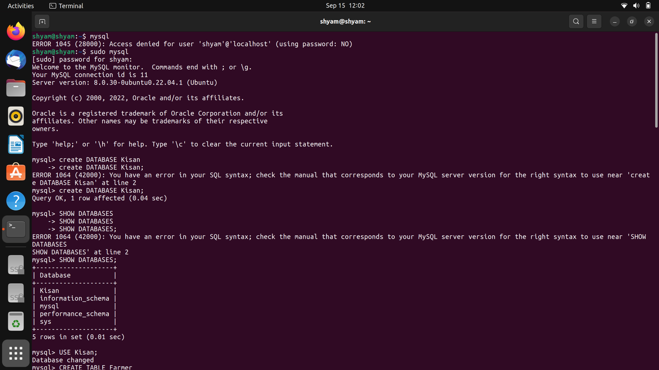

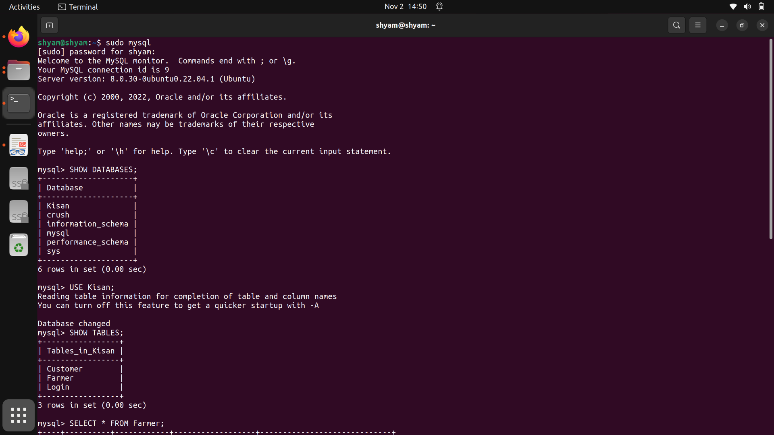

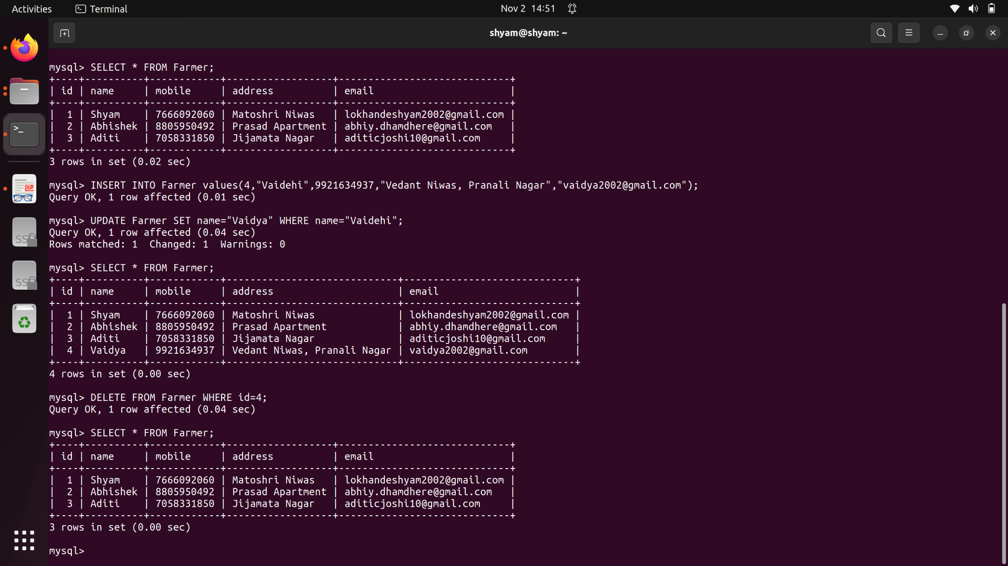

# Conclusion-

Thus, we executed the DDL and DML command queries in SQL.